|  |
| --- |
| cid:image001.jpg@01D5C716.D323BBC0  ***RME Communication*** |

***Equipment Impacted:*** Shipping sorter (Intellisort)

***Associated SME Group:*** Automation engineering

***When Does this Change Occur:*** ASAP

***Issue Description:***

Since the initial launch, many Intelligrated sites have no jam eye protection at the ship sorter scan tunnel. Due to the absence of Jam photo-eye, the conveyance continues to run in a jammed state causing large pile-ups inside the scan tunnel. These have resulted in excessive hours of downtime for the sorter and associated equipment due to damages incurred. Additionally, significant stress on the drive section of the conveyance during these events led to drive misalignment, drive belt damage, and loose tension issues.

***Site Impacted:*** 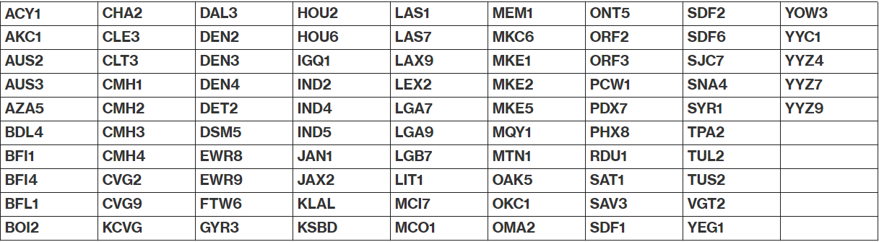

***What’s Changing:***

This quip determines what sites need PE inside the scan tunnels to prevent jams. Once all data is captured, CAR will be submitted to do a network-wide project to get the PE installed before the scan tunnel.

***What Actions are Required for Sites?***

Sites are required to fill out the below quip with the requested information

<https://quip-amazon.com/ZnbQAaS118TV/Ship-sorter-scan-tunnel-PE-audit>

Any sites having difficulty with the quip information should reach out to Aakash Patel([Aakashpl@amazon.com](mailto:Aakashpl@amazon.com)) and CC [rme-rca-central-team@amazon.com](mailto:rme-rca-central-team@amazon.com)

BCC**:** [*na-rme-3p-all@amazon.com*](mailto:na-rme-3p-all@amazon.com)  ; [*na-rme-bb-all@amazon.com*](mailto:na-rme-bb-all@amazon.com)  ; [*plannerschedulers@amazon.com*](mailto:plannerschedulers@amazon.com)  ; [*eam-admins@amazon.com*](mailto:eam-admins@amazon.com)  ; [*nacf-ae-sys-eng@amazon.com*](mailto:nacf-ae-sys-eng@amazon.com)  ; [*nacf-ae-level5-up@amazon.com*](mailto:nacf-ae-level5-up@amazon.com)  ; [*na-rme-bb-srteam@amazon.com*](mailto:na-rme-bb-srteam@amazon.com)  ; [*na-rme-3p-directors@amazon.com*](mailto:na-rme-3p-directors@amazon.com) ; [*na-rme-llirn@amazon.com*](mailto:na-rme-llirn@amazon.com) ; [*ops-engrs-pmo-execution@amazon.com*](mailto:ops-engrs-pmo-execution@amazon.com) ;  [*jll-reliability-rebbl@amazon.com*](mailto:jll-reliability-rebbl@amazon.com) ; [*rme-rca-central-team@amazon.com*](mailto:rme-rca-central-team@amazon.com)

|  |
| --- |
| **Questions? Please email us: rme-rca-central-team@amazon.com** |